**TITLE IN CAPITAL LETTERS TITLE IN CAPITAL LETTERS TITLE IN CAPITAL LETTERS TITLE IN CAPITAL LETTERS**

STUDENT NAME

UNIVERSITY OF TECHNOLOGY

# UNIVERSITY OF TECHNOLOGY

**DECLARATION OF THESIS /POSTGRADUATE PROJECT REPORT AND COPYRIGHT**

Author’s full name : passport name

Title :

Department :

I declare that this thesis is classified as:

# CONFIDENTIAL

**RESTRICTED** (only one year then change the status to open access )

* **OPEN ACCESS** I agree that my thesis to be published as online open access (full text)

1. I acknowledged that University of Technology reserves the right as follows:
2. The thesis is the property of University of Technology
3. The Library of University of Technology has the right to make copies for the purpose of research only.
4. The Library has the right to make copies of the thesis for academic exchange.

Certified by:

**SIGNATURE OF STUDENT SIGNATURE OF SUPERVISOR**

ASD-Ph.D/MS.c 153024

**ID NUMBER NAME OF SUPERVISOR**

Date: 00 November 0000 Date: 00 November 0000

NOTES : If the thesis is CONFIDENTIAL or RESTRICTED, please attach with the letter from the organization with period and reasons for confidentiality or restriction

“I hereby declare that I/we have read this thesis and in my opinion this thesis is sufficient in term of scope and quality for the award of the degree of Doctor of Philosophy in (specialization)”

Signature :

Name of Supervisor I : AAAAAAAAAA Date : 0 NOVEMBER 0000

Signature : Name of Supervisor II : AAAAAAAAA

Date : 0 NOVEMBER 0000

Signature : Name of Supervisor III : AAAAAAAAA

Date : 0 NOVEMBER 2000

# Certificate of the linguistic Supervisor

I certify that this thesis entitled

***Thesis title***

Was prepared by (student name) under my linguistic supervision. Its language was amended to meet the style of English Language.

Signature:

Name: **Dr.**

# Materials Engineering Department University of Technology

Date: / 11 / 2020.

# Examination Committee Certification

We certify that we read the thesis entitled “**thesis title**” and as examined the student **ALI A. ATI** in its content and what is related to, and that in our opinion, it meets the standard of a thesis for the degree of Doctor of Philosophy in Materials Engineering **Signature:**

**Name: Prof. Dr.** (Chairman) Date: / /2020

# Signature: Signature:

## Name: Prof. Dr. Name: Prof. Dr.

(Member) (Member)

Date: / /2020 Date: / /2020

# Signature: Signature:

## Name: Assist. Prof. Dr. Name: Assist. Prof. Dr.

(Member) (Member)

Date: / /2020 Date: / /2020

# Signature: Signature:

## Name: Assist. Pr Name: Assist. Prof. Dr.

(Member) (Member)

Date: / /2020 Date: / /2020

Approved for the Materials Engineering Department

# Signature:

## Name: Assist. Prof. Dr.

Head of Materials Engineering Department

# PART A - Confirmation of Cooperation *

It is confirmed that this thesis has been implemented through collaboration between

by Verified by:

Signature: Data:

Name: Position: (Office stamp)

*\* If the preparation of a thesis or project involves collaboration.*

ON-LINE RECOGNITION OF DEVELOPING CONTROL CHART PATTERNS TITLE

TITLE TITLE

Student name

A thesis submitted in partial fulfilment of the requirements for the degree of

Doctor of Philosophy in Mechanical Engineering

Mechanical Engineering Department University of Technology

November 2020

# DECLARATION

I declare that this thesis entitled *“title of the thesis”* is the result of my own research except as cited in the references. The thesis has not been accepted for any degree and is not concurrently submitted in candidature of any other degree.

Signature : ....................................................

Name :

Date : 00 NOVEMBER 2016

# DEDICATION

This thesis is dedicated to my father, who taught me that the best kind of knowledge to have is that which is learned for its own sake. It is also dedicated to my

mother, who taught me that even the largest task can be accomplished if it is done one step at a time.

# ACKNOWLEDGEMENT

In preparing this thesis, I was in contact with many people, researchers, academicians, and practitioners. They have contributed towards my understanding and thoughts. In particular, I wish to express my sincere appreciation to my main thesis supervisor, Professor Dr. A. A. A for encouragement, guidance, critics and friendship. I am also very thankful to my co-supervisor Professor Dr A. H. A and Associate Professor Dr. H. J for their guidance, advices and motivation. Without their continued support and interest, this thesis would not have been the same as presented here.

I am also indebted to University of Technology (UOT), Applied Science Department for funding/supporting my Ph.D/MS.c study. Librarians at UOT, university of Baghdad, and Universiti Teknologi Malaysia (UTM) also deserve special thanks for their assistance in supplying the relevant literatures.

My fellow postgraduate student should also be recognised for their support. My sincere appreciation also extends to all my colleagues and others who have provided assistance at various occasions. Their views and tips are useful indeed. Unfortunately, it is not possible to list all of them in this limited space. I am grateful to all my family member.

# ABSTRACT

The purpose of this study is to investigate the application of genetic algorithm (GA) in modelling linear and non-linear dynamic systems and develop an alternative model structure selection algorithm based on GA. Orthogonal least square (OLS), a gradient descent method was used as the benchmark for the proposed algorithm. A model structure selection based on modified genetic algorithm (MGA) has been proposed in this study to reduce problems of premature convergence in simple GA (SGA). The effect of different combinations of MGA operators on the performance of the developed model was studied and the effectiveness and shortcomings of MGA were highlighted. Results were compared between SGA, MGA and benchmark OLS method. It was discovered that with similar number of dynamic terms, in most cases, MGA performs better than SGA in terms of exploring potential solution and outperformed the OLS algorithm in terms of selected number of terms and predictive accuracy. In addition, the use of local search with MGA for fine-tuning the algorithm was also proposed and investigated, named as memetic algorithm (MA). Simulation results demonstrated that in most cases, MA is able to produce an adequate and parsimonious model that can satisfy the model validation tests with significant advantages over OLS, SGA and MGA methods. Furthermore, the case studies on identification of multivariable systems based on real experiment t al data from two systems namely a turbo alternator and a continuous stirred tank reactor showed that the proposed algorithm could be used as an alternative to adequately identify adequate and parsimonious models for those systems. Abstract must be bilingual. For a thesis written in Bahasa Melayu, the abstract must first be written in Bahasa Melayu and followed by the English translation. If the thesis is written in English, the abstract must be written in English and followed by the translation in Bahasa Melayu. The abstract should be brief, written in one paragraph and not exceed one



(1) page. An abstract is different from synopsis or summary of a thesis. It should states the field of study, problem definition, methodology adopted, research process, results obtained and conclusion of the research. The abstract can be written using single or one and a half spacing..

# المستحلص

500 words maximum for Ph.D 300 words maximum for Master

# TABLE OF CONTENTS

**TITLE PAGE**

DECLARATION iii

DEDICATION iv

ACKNOWLEDGEMENT v

ABSTRACT vi

صلختسملا Error! Bookmark not defined.

TABLE OF CONTENTS viii

LIST OF TABLES x

LIST OF FIGURES xi

LIST OF ABBREVIATIONS xii

LIST OF SYMBOLS xiii

LIST OF APPENDICES xiv



|  |  |  |
| --- | --- | --- |
| **CHAPTER 1**  1.1 | **INTRODUCTION**  Problem Background | **1**  1 |
| 1.2 | Problem Background | 1 |
| 1.3 | Problem Statement | 2 |
| 1.4 | Research Goal | 2 |
|  | 1.4.1 Research Objectives | 2 |
| 1.5 | Captions | 2 |
| 1.6 | Quotation | 3 |
| 1.7 | Equation | 3 |

|  |  |  |
| --- | --- | --- |
| **CHAPTER 2** | **LITERATURE REVIEW** | **5** |
| 2.1 | Introduction | 5 |
|  | 2.1.1 State-of-the-Arts | 5 |
| 2.2 | Limitation | 5 |
| 2.3 | Research Gap | 5 |

|  |  |  |
| --- | --- | --- |
| **CHAPTER 3** | **RESEARCH METHODOLOGY** | **7** |
| 3.1 | Introduction | 7 |
|  | 3.1.1 Proposed Method | 7 |

3.1.2 Research Activities 7

* 1. Tools and Platforms 8
  2. Chapter Summary 8

|  |  |  |
| --- | --- | --- |
| **CHAPTER 4** | **PROPOSED WORK** | **9** |
| 4.1 | The Big Picture | 9 |
| 4.2 | Analytical Proofs | 9 |
| 4.3 | Result and Discussion | 10 |
| 4.4 | Chapter Summary | 10 |

|  |  |  |
| --- | --- | --- |
| **CHAPTER 5** | **CONCLUSION AND RECOMMENDATIONS** | **13** |
| 5.1 | Research Outcomes | 13 |
| 5.2 | Contributions to Knowledge | 13 |
| 5.3 | Future Works | 13 |

# REFERENCES 15

**LIST OF PUBLICATIONS 17**

# LIST OF TABLES

**TABLE NO. TITLE PAGE**

Table 1.1 The role of statistical quality engineering tools and methodologies 3

|  |  |  |
| --- | --- | --- |
| Table 1.2 | Basic ANN models used for control chart pattern recognition | 3 |
| Table 2.1 | Regression analysis for the results of preliminary feature screening | 5 |
| Table 2.2 | Estimated effects and regression coefficients for the recogniser's performance (reduced model) | 5 |
| Table 5.1 | Example Repeated Header Table. | 13 |

**FIGURE NO. TITLE PAGE**

Figure 1.1 Trends leading to the problem using MZJ Formatting Method. 2

**Figure 1.2** Design and development phases of the proposed scheme [1] 3

|  |  |  |
| --- | --- | --- |
| Figure 2.1 | Continuous variability reduction using SPC chart (Revelle and Harrington, 1992) | 5 |
| Figure 2.2 | Typical fully developed patterns on Shewhart control chart (Cheng, 1989) | 5 |
| Figure 3.1 | Example of Formatting Method. | 8 |
| Figure 4.1 | This is MZJ original idea. | 9 |
| Figure 4.2 | The method for high performance formatting. | 10 |

ANN - Artificial Neural Network GA - Genetic Algorithm

PSO - Particle Swarm Optimization MTS - Mahalanobis Taguchi System MD - Mahalanobis Distance

TM - Taguchi Method

UOT - University of Technology XML - Extensible Markup Language ANN - Artificial Neural Network GA - Genetic Algorithm

PSO - Particle Swarm Optimization

δ - Minimal error

*D*, *d* - Diameter

*F* - Force

*v* - Velocity

*p* - Pressure

*I* - Moment of Inersia

*r* - Radius

Re - Reynold Number

**APPENDIX TITLE PAGE**

Appendix C Time-series Results Long Long Long Long Long Long

Long Long Long Long 16

# CHAPTER 1 INTRODUCTION

* 1. **Problem Background**

Video provides a powerful way to help you prove your point. When you click Online Video, you can paste in the embed code for the video you want to add. You can also type a keyword to search online for the video that best fits your document. To make your document look professionally produced, Word provides header, footer, cover page, and text box designs that complement each other. For example, you can add a matching cover page, header, and sidebar. *“For the thesis paragraphs, use ‘Para 1.5 lines’ style”*

Video provides a powerful way to help you prove your point. When you click Online Video, you can paste in the embed code for the video you want to add. You can also type a keyword to search online for the video that best fits your document. To make your document look professionally produced, Word provides header, footer, cover page, and text box designs that *complement* each other. For example, you can add a matching cover page, header, and sidebar. Click Insert and then choose the elements you want from the different galleries. Themes and styles also help keep your document coordinated. When you click Design and choose a new Theme, the pictures, charts, and SmartArt graphics change to match your new theme. *“For the last paragraph/single paragraph in the section, use ‘Para 1.5 lines’ style”.*



# Problem Background

Video provides a powerful way to help you prove your point. When you click Online Video, you can paste in the embed code for the video you want to add. You can also type a keyword to search online for the video that best fits your document. To make your document look professionally produced, Word provides header, footer, cover page, and text box designs that complement each other. For example, you can add a matching cover page, header, and sidebar. Click Insert and then choose the elements you want from the different galleries.

Themes and styles also help keep your document coordinated. When you click Design and choose a new Theme, the pictures, charts, and SmartArt graphics change to match your new theme. When you apply styles, your headings change to match the new theme. Save time in Word with new buttons that show up where you

need them. To change the way a picture fits in your document, click it and a button for layout options appears next to it. When you work on a table, click where you want to add a row or a column, and then click the plus sign.

# Problem Statement

* 1. **Research Goal**

**1.4.1 Research Objectives**

The objectives of the research are :

1. To estimate the parameters
2. Item 1
3. Item 2
4. To define the best parameter estimate.

# Captions

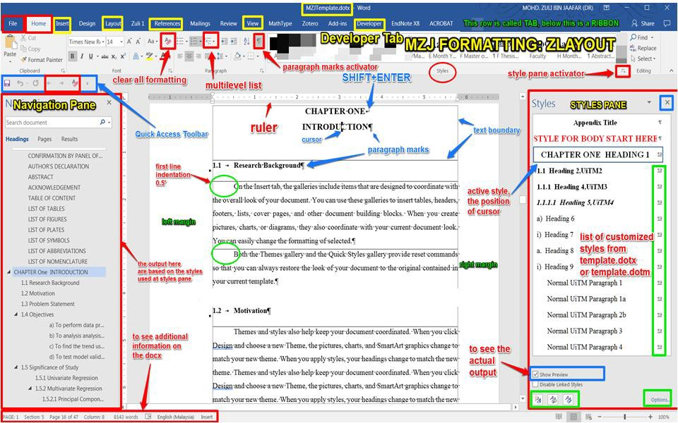

Figure 1.1 Trends leading to the problem using MZJ Formatting Method.

*(Distance between the caption and figure one line)*

**Figure 1.2** Design and development phases of the proposed scheme [1]

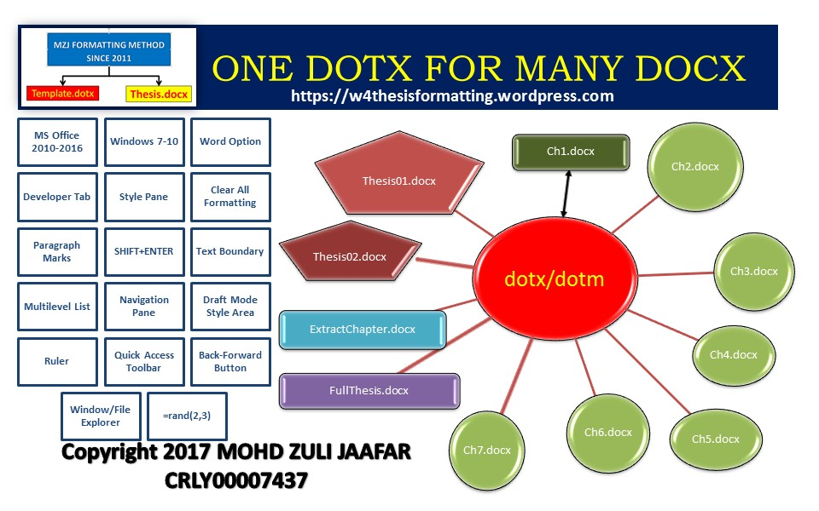

*(If the caption is written more than one line, use 1.5 line)*

Table 1.1 The role of statistical quality engineering tools and methodologies



*(If the caption is written in a single line)*

Table 1.2 Basic ANN models used for control chart pattern recognition

*(If the caption is written more than one line, use 1.5 line)*

# Quotation

After deliberating on doctoral education in Australia in the 1990s, one observer I Australia writes:

The lack of any significant formal course work within our Ph.D. and master degrees by research has continued for three decades. The focus of our Ph.D. research type degrees continues to be the research project, and this is almost the only medium by which education is accomplished.

# Equation

*y*  *mx*  *c*

(1.1)

Video provides a powerful way to help you prove your point. When you click Online Video, you can paste in the embed code for the video you want to add. You can also type a keyword to search online for the video that best fits your document. To make your document look professionally produced, Word provides header, footer, cover page, and text box designs that complement each other. For example, you can

add a matching cover page, header, and sidebar. Click Insert and then choose the elements you want from the different galleries. Themes and styles also help keep your document coordinated. When you click Design and choose a new Theme, the pictures, charts, and SmartArt graphics change to match your new theme. When you apply styles, your headings change to match the new theme. Save time in Word with new buttons that show up where you need them.

To change the way a picture fits in your document, click it and a button for layout options appears next to it. When you work on a table, click where you want to add a row or a column, and then click the plus sign. Reading is easier, too, in the new Reading view. You can collapse parts of the document and focus on the text you want. If you need to stop reading before you reach the end, Word remembers where you left off - even on another device. Video provides a powerful way to help you prove your point. When you click Online Video, you can paste in the embed code for the video you want to add. You can also type a keyword to search online for the video that best fits your document. To make your document look professionally produced, Word provides header, footer, cover page, and text box designs that complement each other. For example, you can add a matching cover page, header, and sidebar.



# CHAPTER 2 LITERATURE REVIEW

* 1. **Introduction**

Video provides a powerful way to help you prove your point. When you click Online Video, you can paste in the embed code for the video you want to add. You can also type a keyword to search online for the video that best fits your document. To make your document look professionally produced, Word provides header, footer, cover page, and text box designs that complement each other. For example, you can add a matching cover page, header, and sidebar.

Figure 2.1 Continuous variability reduction using SPC chart (Revelle and Harrington, 1992)

Figure 2.2 Typical fully developed patterns on Shewhart control chart (Cheng, 1989)

Table 2.1 Regression analysis for the results of preliminary feature screening Table 2.2 Estimated effects and regression coefficients for the recogniser's performance (reduced model)



Video provides a powerful way to help you prove your point. When you click Online Video, you can paste in the embed code for the video you want to add. You can also type a keyword to search online for the video that best fits your document. To make your document look professionally produced, Word provides header, footer, cover page, and text box designs that complement each other. For example, you can add a matching cover page, header, and sidebar.

# 2.1.1 State-of-the-Arts

* 1. **Limitation**
  2. **Research Gap**

1. Video provides a powerful way to help you prove your point.
2. When you click Online Video, you can paste in the embed code for the video you want to add.
3. You can also type a keyword to search online for the video that best fits your document.
4. To make your document look professionally produced, Word provides header, footer, cover page, and text box designs that complement each other.



1. For example, you can add a matching cover page, header, and sidebar.

Video provides a powerful way to help you prove your point. When you click Online Video, you can paste in the embed code for the video you want to add. You can also type a keyword to search online for the video that best fits your document. To make your document look professionally produced, Word provides header, footer, cover page, and text box designs that complement each other. For example, you can add a matching cover page, header, and sidebar.

Click Insert and then choose the elements you want from the different galleries. Themes and styles also help keep your document coordinated. When you click Design and choose a new Theme, the pictures, charts, and SmartArt graphics change to match your new theme. When you apply styles, your headings change to match the new theme. Save time in Word with new buttons that show up where you need them.

To change the way a picture fits in your document, click it and a button for layout options appears next to it. When you work on a table, click where you want to add a row or a column, and then click the plus sign. Reading is easier, too, in the new Reading view. You can collapse parts of the document and focus on the text you want. If you need to stop reading before you reach the end, Word remembers where you left off - even on another device.



Video provides a powerful way to help you prove your point. When you click Online Video, you can paste in the embed code for the video you want to add. You can also type a keyword to search online for the video that best fits your document. To make your document look professionally produced, Word provides header, footer, cover page, and text box designs that complement each other. For example, you can add a matching cover page, header, and sidebar.

Click Insert and then choose the elements you want from the different galleries. Themes and styles also help keep your document coordinated. When you click Design and choose a new Theme, the pictures, charts, and SmartArt graphics change to match your new theme. When you apply styles, your headings change to match the new theme. Save time in Word with new buttons that show up where you need them.

# CHAPTER 3 RESEARCH METHODOLOGY

* 1. **Introduction**

On the Insert tab, the galleries include items that are designed to coordinate with the overall look of your document. You can use these galleries to insert tables, headers, footers, lists, cover pages, and other document building blocks. When you create pictures, charts, or diagrams, they also coordinate with your current document look. You can easily change the formatting of selected text in the document text by choosing a look for the selected text from the Quick Styles gallery on the Home tab.

# 3.1.1 Proposed Method

On the Insert tab, the galleries include items that are designed to coordinate with the overall look of your document. You can use these galleries to insert tables, headers, footers, lists, cover pages, and other document building blocks. When you create pictures, charts, or diagrams, they also coordinate with your current document look. You can easily change the formatting of selected text in the document text by choosing a look for the selected text from the Quick Styles gallery on the Home tab.



# 3.1.1.1 Research Activities

On the Insert tab, the galleries include items that are designed to coordinate with the overall look of your document [1]. You can use these galleries to insert tables, headers, footers, lists, cover pages, and other document building blocks. When you create pictures, charts, or diagrams, they also coordinate with your current document look. You can easily change the formatting of selected text in the document text by choosing a look for the selected text from the Quick Styles gallery on the Home tab.

# Tools and Platforms

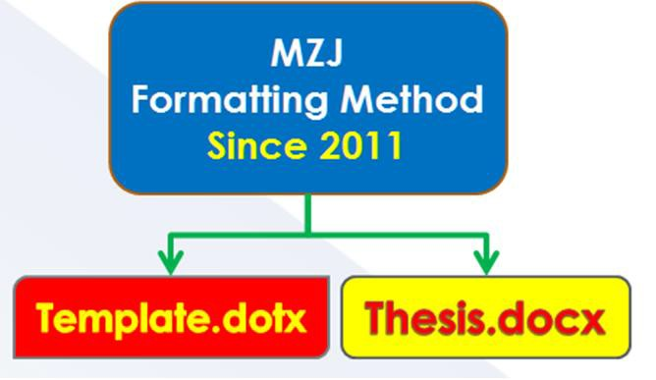

Figure 3.1 Example of Formatting Method.

# Chapter Summary

1. Video provides a powerful way to help you prove your point.
2. When you click Online Video, you can paste in the embed code for the video you want to add.
3. You can also type a keyword to search online for the video that best fits your document.



1. To make your document look professionally produced, Word provides header, footer, cover page, and text box designs that complement each other.
2. For example, you can add a matching cover page, header, and sidebar.

# CHAPTER 4 PROPOSED WORK

* 1. **The Big Picture**

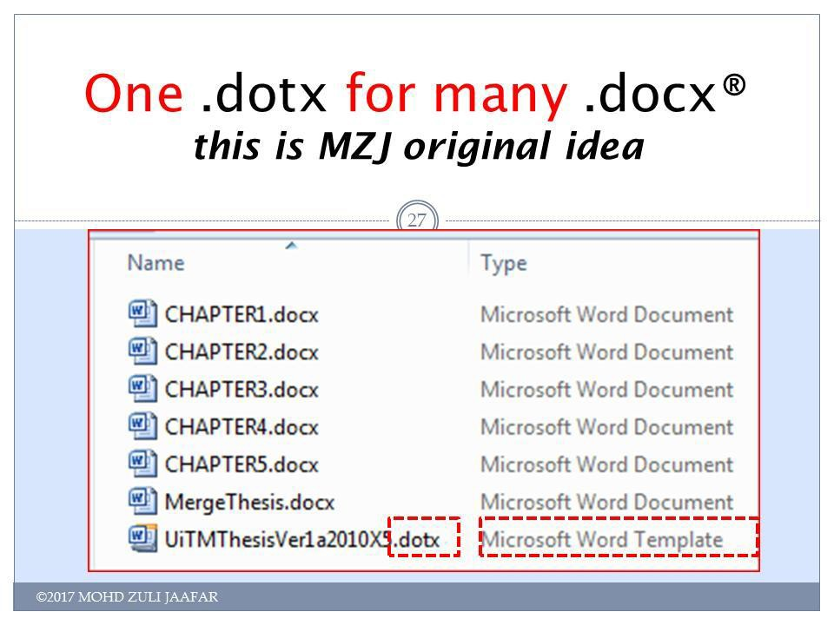

Figure 4.1 This is MZJ original idea.

# Analytical Proofs

1. Video provides a powerful way to help you prove your point.
2. When you click Online Video, you can paste in the embed code for the video you want to add.
3. You can also type a keyword to search online for the video that best fits your document.
4. To make your document look professionally produced, Word provides header, footer, cover page, and text box designs that complement each other.
5. For example, you can add a matching cover page, header, and sidebar.

# Result and Discussion

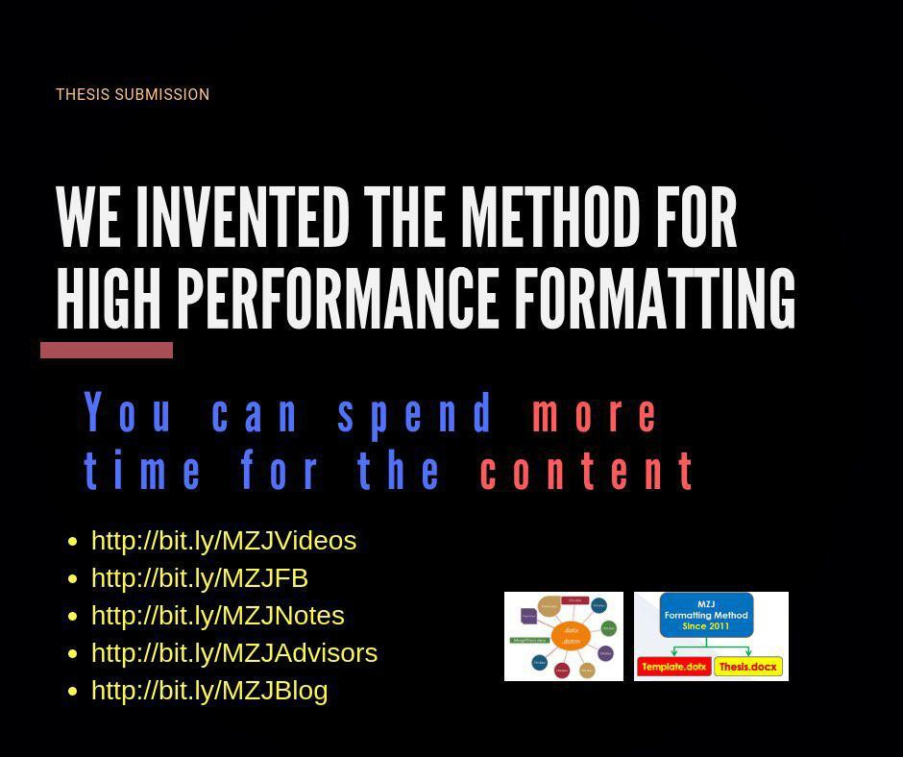

Figure 4.2 The method for high performance formatting.

# Chapter Summary

*Chapter No. Chapter Title*

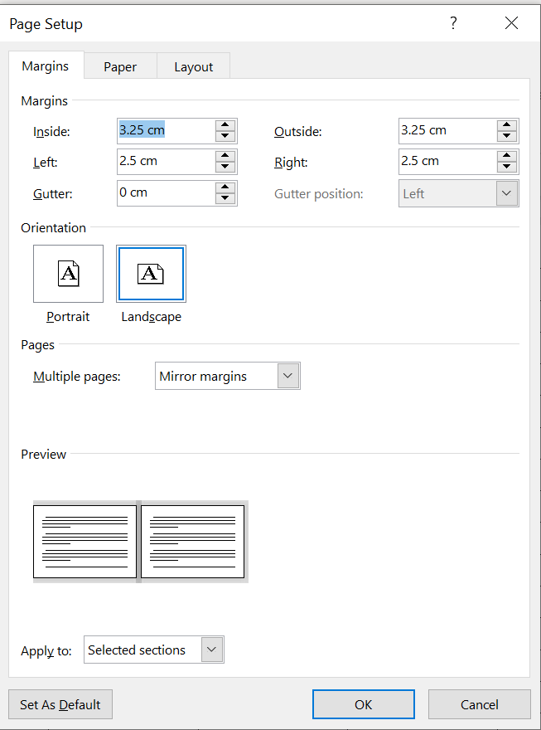

Title Title Ti Title Title

tle Title Title

11

# CHAPTER 5

**CONCLUSION AND RECOMMENDATIONS**

* 1. **Research Outcomes**
  2. **Contributions to Knowledge**
  3. **Future Works**

Video provides a powerful way to help you prove your point. When you click Online Video, you can paste in the embed code for the video you want to add. You can also type a keyword to search online for the video that best fits your document.

Table 5.1 Example Repeated Header Table.



Title Title Title Title

|  |  |  |  |
| --- | --- | --- | --- |
| Title | Title | Title | Title |
|  |  |  |  |
|  |  |  |  |

Video provides a powerful way to help you prove your point. When you click Online Video, you can paste in the embed code for the video you want to add. You can also type a keyword to search online for the video that best fits your document. To make your document look professionally produced, Word provides header, footer, cover page, and text box designs that complement each other.



# REFERENCES



**Appendix A Time-series Results Long Long Long Long Long Long Long Long Long Long**



**LIST OF PUBLICATIONS**

[1] M.I. Sayyed, A.A. Ati, M.H.A. Mhareb, K.A. Mahmoud, K.M. Kaky, S.O. Baki,

M.A. Mahdi, Novel tellurite glass (60-x)TeO2–10GeO2 -20ZnO–10BaO - xBi2O3 for radiation shielding, Journal of Alloys and Compounds, 844 (2020) 155668.

